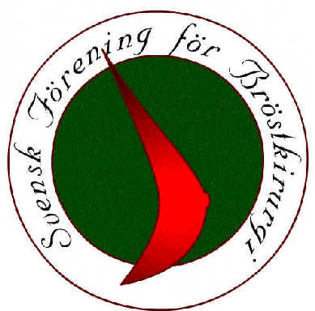

1st National Oncoplastic Workshop (NOW) Sweden:
Focus on Breast Conservation
May 18-20, 2020
Steningevik Konferens, Märsta, www.steningevik.se

Supported by:

Monday, May 18, 2020: Focus on reduction mammaplasty techniques
9:30 Welcome
9:45-10:15 Update: what is the current evidence regarding breast conservation in large-volume disease and oncological outcomes?
Jana de Boniface
10:15-10:45 Extreme oncoplastics: can we go too far?
Elisabeth Elder
Coffee break
11:00-12:00 Simple is best: experiences, learning curves, pitfalls
Kristjan Asgeirsson
Lunch
13:00-14:00 The Nottingham algorithm: a quadrant-to-quadrant approach to volume displacement
Douglas MacMillan

Quadrant-wise case discussion, video tutorials, mark-up on live models
14:10-14:40 Upper outer quadrant (moderator: Jana de Boniface)
14:40-15:10 Upper inner quadrant (moderator: Tor Svensjö)
Coffee break
15:40-16:10 Lower outer quadrant (moderator: Pia Olofsson)
16:10-16:40 Lower inner quadrant (moderator: Elisabeth Elder)

17:00-18:00 Complex mammaplasty: case scenarios and mark-up on live models
All faculty

19:30 Dinner

Tuesday, May 19, 2020: Focus on volume replacement and special scenarios
8:30-9:00 Update: what is the current evidence regarding the clinical and oncological safety of and the indications for volume replacement?
Tor Svensjö
9:00-10:00 Perforator flaps: how to get started
Douglas MacMillan
10:00-10:45 Avoiding and handling complications in volume replacement
Kristjan Asgeirsson
Coffee break
11:15-12:15 Training session: perforator identification and mark-up on live models
All faculty
Lunch
Sponsor presentations:
13:15-13:30 Promeduc
13:30-13:45 Amoena

Complex clinical situations I: breast cancer surgery in the cosmetically operated patient
13:45-14:15 The Swedish approach (Tor Svensjö)
14:15-14:45 The English approach (Kristjan Asgeirsson/Douglas MacMillan)
14:45-15:15 The Australian approach (Elisabeth Elder)

Coffee break

Complex clinical situations II: breast conservation in extensive DCIS
15:45-16:15 The Swedish approach (Jana de Boniface)
16:15-16:45 The English approach (Kristjan Asgeirsson/Douglas MacMillan)
16:45-17:15 The Australian approach (Elisabeth Elder)

19:00 Dinner

Wednesday, May 20, 2020: case presentations and discussion (Swedish)

8:30-9:30 Submitted cases 1-4
9:45-10:45 Submitted cases 5-8
Coffee break
11:15-12:15 Submitted cases 9-12

12:15-12:30 Wrap-up and feed-back

Lunch for those who wish (please register!)

